# Subqueries 2

The following exercises use the “supermarket” database. For simplicity, use the view that returns all data, which we created before. For ease of writing the code, replace the spaces in names with underscores like so:

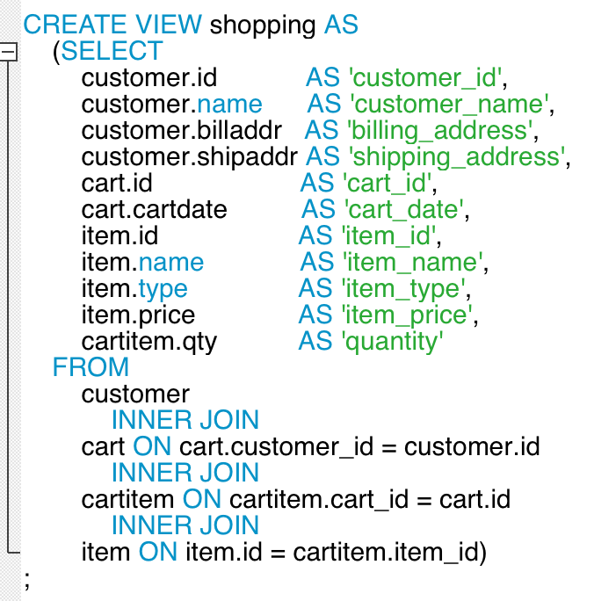

1. Get customer id, customer name and price of the most expensive item a customer bought overall. Use the GROUP BY clause.
2. Like the above, but additionally with item id, item name and item price. Convince yourself that this can only be done with a subquery. Use a correlated subquery.
3. Same as last problem, but use an INNER JOIN with a GROUP BY intermediate table that returns the customer id and max price.
4. Similar to the above but one step further; most expensive item, per customer, per cart. In addition to customer id, customer name, item id, item name and max price, also return the cart id. Use correlated subquery.
5. Same as last, but with INNER JOIN and GROUP BY clause.
6. Determine average price of items a customer bought. Return customer id, customer name and average price. Hint: one way to solve this problem is to use a GROUP BY intermediate table that is GROUPed BY again.